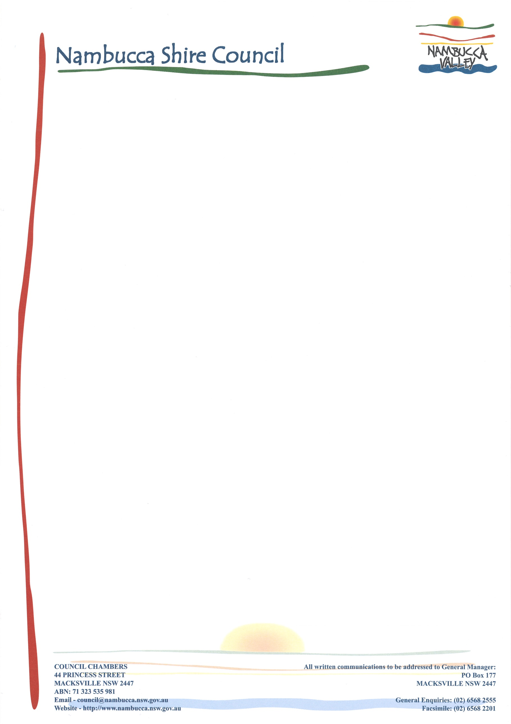*Enquiries to:* Mr Grant Nelson

*Phone No:* 6568 0248

*Our Ref:* SF600

20 December 2020

Craig Diss

Team Leader, Northern Region

NSW Department of Planning and Environment

Locked Bag 9022

Grafton NSW 2460

Dear Sir

**PLANNING PROPOSAL - NAMBUCCA LOCAL ENVIRONMENTAL PLAN 2010 -**

**AMENDMENT NO 25 – RECLASSIFICATION of Lot 482 DP 700681, 2 South Arm Road Bowraville**

I refer to the above mentioned planning proposal to amend the Nambucca Local Environmental Plan 2010 (LEP). The proposal includes LEP amendments that relate to the community classified Council reserve at 2 South Arm Road Bowraville.

On the 26th September 2019 Council resolved to amend to the Nambucca LEP 2010 to support the reclassification and future disposal of part of this public reserve as described in the planning proposal. Please find attached a copy of the planning proposal, council report and minutes from the meeting.

Pursuant to clause 3.34 of the Environmental Planning and Assessment Act 1979 Council submits this planning proposal to the Department of Planning and Environment for your favourable consideration and gateway determination. Council is not seeking delegated authority to proceed with the amendment.

Should you have any queries in regards to this or require additional information please do not hesitate to contact Mr Grant Nelson (02) 6568 0248.

Yours faithfully

**Grant Nelson**

**COORDINATOR OF STRATEGIC PLANNING AND NATURAL RESOURCES**

Gn:GN